Department of Information Technology

Semester: V Name of Student:
Academic Year: 2022-23 Student ID:
Class / Branch: TE IT
Subject: Security Lab (SL)
Name of Instructor: Prof. Apeksha Mohite

EXPERIMENT NO. 1
Aim: To Demonstrate IP Spoofing and ARP Spoofing in Local Area Network.
Demonstration of IP Spoofing:
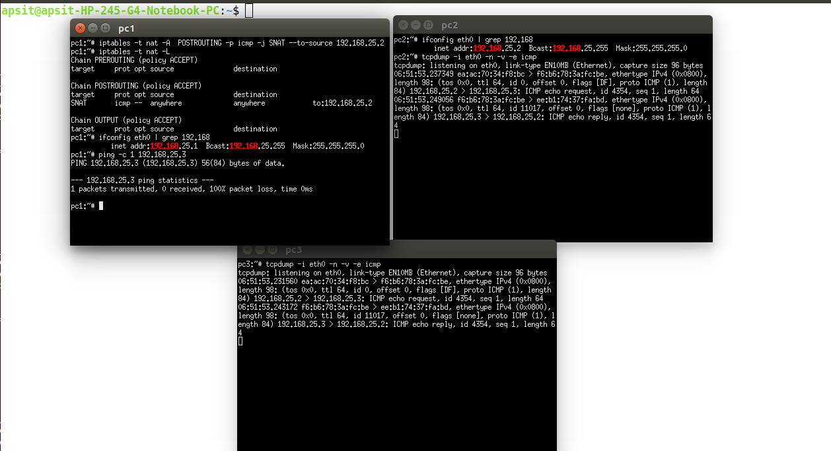
Demonstration of MAC Spoofing:
Checking arpwatch status after Installation :
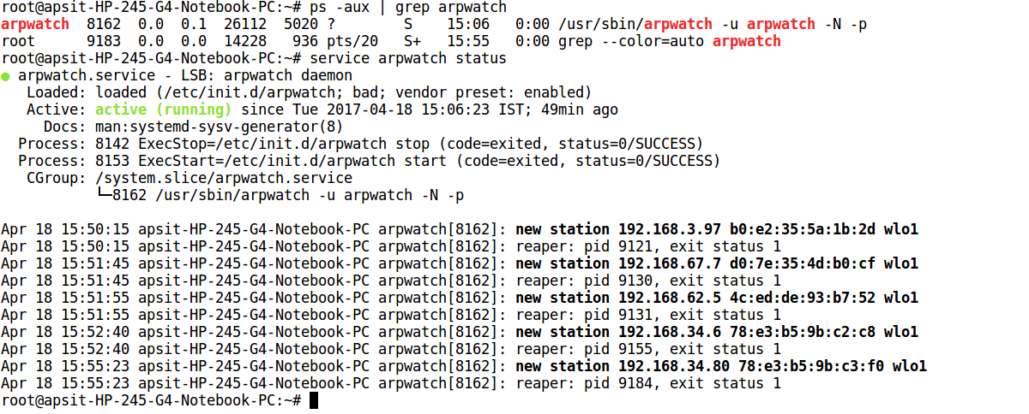
Displaying MAC Address of Remote Host:
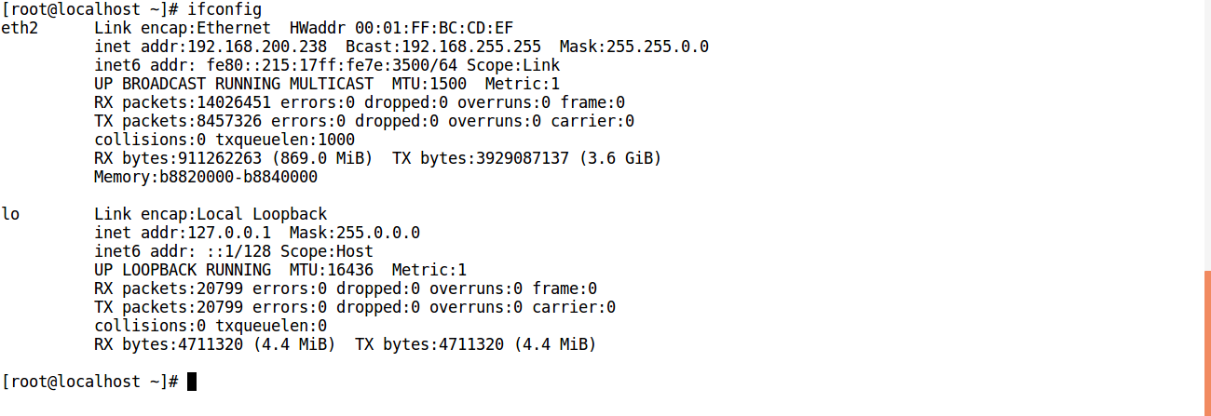

Changing MAC of Remote Host with ifconfig:
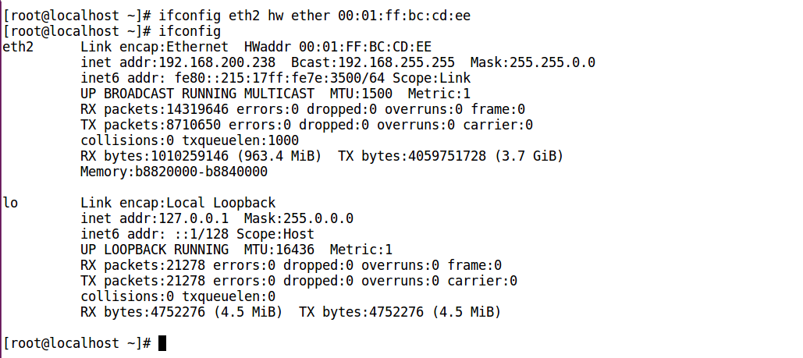
arpwatch running on Local Machine logs changed MAC of remote host :
